
Al-Balqa Applied University

Prince Abdullah Bin Ghazi Faculty of Information & Communication Technology

Department of Computer Science
PARTY.JO

Wedding & Party Services Platform

SRS (SOFTWARE REQUIREMENT SPECIFICATION)
Version 1.0
Presented by:
Hamzah Ghnimat, Mohab Omar, Qusai Alhaj

Supervised By:
Dr. Khalaf Khatatneh, Dr. Zaid Al-Laxmi
12/4/2026
TABLE CONTENT

TITLE PAGE……………………………………………………..…..1
INTRODUCTION…………………………………………………....3
DEFINITIONS……………………………………………………….3
SCOPE…………………………………………………………….….4
FUNCTIONAL REQUIREMENTS………………………………...5

NON-FUNCTIONAL REQUIREMENTS (NFRS)………………..10
1.WIREFRAME……………………………………………………..13
1.1 Homepage………….………………………………..………………..……?
1.2 Groom, Bride, Client Page…………..……………….……………..…….?
1.3 Service Provider page……………………………………………….…….?

2.MOCKUPS ………………………………………………………...16
2.1 Homepage ………………………………………………………...…....?
2.2 Service provider page………………….………………………………?
2.3 Manager page………………………………………………………….?
2.4 Women page……………………………………………………...........?
2.5 Basket page…………………………………………………………….?

INTRODUCTION

This document provides a detailed description of all the technical aspects that will be implemented in the Customer Relationship Management (CRM) system. It has 4 sections: Introduction, Functional Requirements, Non-Functional Requirements, and Wireframes.

This website will greatly simplify wedding and event planning, offering high flexibility. It will organize all wedding and event pricing and provide clients with access to photos from past weddings or events in a separate section.
The system will make it easier to access all our services, making customers more relaxed, and will also allow service providers to offer their services in full detail.

DEFINITION

SRS (Software Requirement Specification): A document describing all requirements of the Party.jo platform.
JWT (JSON Web Token): A secure token generated after login to identify the user across requests.
RBAC (Role-Based Access Control): A mechanism that controls what each user type can access within the system.
ORM (Object-Relational Mapping): A Laravel feature that allows the backend to interact with MySQL using PHP instead of raw SQL.
HTTP (HyperText Transfer Protocol): The protocol used to transfer requests and responses between the frontend and backend.
JSON (JavaScript Object Notation): A data format used to exchange information between the frontend and backend.
SMTP (Simple Mail Transfer Protocol): A protocol used by Laravel to send automated email notifications to users and providers

SCOPE IN, SCOPE OUT
Within The Scope of the project: The website will also gather all services beneficial to clients and couples, making it easier for service providers to add their offerings and other features, gather all pricing information, and submit offers.

Out of Scope
- Integration of external social media platforms
- Human Resources or payroll management
- Resource management
- Legal and contractual services: The platform will not create, validate, or manage any legal contracts
- Mobile application: The scope of the project is limited to an online platform only

FUNCTIONAL REQUIREMENTS

When the client, the couple, and the service provider open the website, the system should display a "Log In" button. After clicking it, the system should prompt the client to enter their email address (required, prefixed with @) and password (text, symbols, integers). Furthermore, upon the client's return, the email address should be accessible without requiring a login in the email text box. The HTML/CSS/JS frontend sends the credentials via an HTTP POST request to the Laravel backend. The Laravel Controllers & Routing layer receives the request, passes it through the Business Logic & Auth layer to validate the credentials against the MySQL database using Eloquent ORM, and returns a JSON response containing the session token. The user's email is stored in MySQL to enable the auto-fill feature on return visits.

When the administrator opens the website, the system should grant the administrator a unique account to access their various services, using the same login process as the user. The same HTTP POST request flow is used. The Laravel Business Logic & Auth layer queries MySQL via Eloquent ORM, identifies the admin role, and returns a role-scoped JSON response that unlocks admin-only routes and dashboard features on the HTML/CSS/JS frontend.

When the client, the couple, and the service provider open the website, the system should provide them with a "Description" button. After clicking it, the system will display a video and a text-only paragraph explaining the website. Clicking the Description button causes the HTML/CSS/JS frontend to send an HTTP GET request to the Laravel backend. The Laravel Controllers & Routing layer retrieves the video URL and description text from MySQL via Eloquent ORM and returns them as a JSON response for the frontend to render dynamically.

Next, the client, the couple, and the service provider will see sections for each category in a button box. When the client clicks any button, the website should open the services bas ed on the selected option. Each category button on the HTML/CSS/JS frontend triggers an HTTP GET request to the Laravel backend. The Laravel Controllers & Routing layer handles the request, and the Models & Eloquent ORM layer queries MySQL for the matching services, returning a JSON array that the frontend renders dynamically.

The first section, "Groom," when clicked, should generate a list of six subsections, each containing a service. When clicking on any service, the system should display all available services according to the service provider. The HTML/CSS/JS frontend sends an HTTP GET request to the Laravel backend. The Laravel Controllers & Routing layer uses Models & Eloquent ORM to query MySQL for the six groom subsections and their linked service provider records, then returns a structured JSON response to the frontend for display.

As for the second section, "Bride," clicking on it should display a list of six sub-sections, each containing a service. When you click on any service, the system displays all available services according to the service provider. Additionally, if the bride selects a service and clicks the "Submit" button, the service and its price are added to the "Basket" section. Clicking Submit triggers an HTTP POST request from the HTML/CSS/JS frontend to the Laravel backend. The Laravel Data Validation layer checks the submitted data, and the Models & Eloquent ORM layer stores the selected service and price in the MySQL database linked to the user's session. A JSON response is returned to update the Basket on the frontend.

As for the third section, "Client," clicking on it will display a list of seven subcategories, each containing a service. When you click on any service, the system displays all available services according to the service provider. Additionally, if the customer selects a service and clicks the "Submit" button, the service and its price are added to the "Basket" section. Clicking Submit sends an HTTP POST request from the HTML/CSS/JS frontend to the Laravel backend. The Data Validation layer validates the input, and the Models & Eloquent ORM layer writes the service and price to the MySQL database. The Laravel backend returns a JSON response that the frontend uses to update the Basket instantly.

The system should display the "Basket" at the top of the website. When opened, all selected services are displayed, along with the product name and price. All prices are then compiled at the bottom of the page. After clicking the "Book" button, the system sends the booking information to the service provider via the website, WhatsApp, and email. The Basket data is loaded via an HTTP GET request to the Laravel backend, which retrieves all session-linked services from MySQL using Eloquent ORM and returns them as JSON. Clicking Book sends an HTTP POST request to the Laravel backend. The Business Logic layer stores the booking in MySQL, then triggers three parallel actions: an in-app notification, a WhatsApp message, and an SMTP email to the service provider — all initiated server-side by Laravel.

The system should also include an "Offers" button to display all offers and discounts provided by the service provider, allowing customers to view all available deals in one place when they visit the website. Clicking the Offers button causes the HTML/CSS/JS frontend to send an HTTP GET request to the Laravel backend. The Controllers & Routing layer uses Eloquent ORM to fetch all active discount records from MySQL and returns them as a JSON array for the frontend to display.

When a service provider opens their section, the system should present multiple options for entering information about their organization. The system will then send all this information to the "Services" manager page, where the manager will decide whether to approve or reject it. If the manager agrees, the service provider can write up their services. The registration form on the HTML/CSS/JS frontend submits the organization data via an HTTP POST request to the Laravel backend. The Data Validation layer checks all fields, and the Models & Eloquent ORM layer stores the data in the MySQL providers table with a "pending" status. The Laravel Business Logic layer then updates the manager's dashboard with a new pending entry retrieved via a SQL query.

This option will appear for the service provider if the manager approves their service. By clicking on the "Service Provider" section and then selecting "Add Service," they can add their service in the "Write" box. Additionally, the service provider will see several options (radio buttons) for each service on the website. By clicking on any service, a text box will appear allowing him to enter all the details of his services and send them to the relevant department to show each of the following services: car rental, barbershops, wedding halls, land rental, restaurants, suit sales, dress rental, beauty services, henna salons, photographers, farm rental, venue rental, and party planning services. Submitting a new service sends an HTTP POST request from the HTML/CSS/JS frontend to the Laravel backend. The Controllers & Routing layer directs it to the correct controller based on the selected radio button. The Data Validation layer checks the content, and the Models & Eloquent ORM layer writes the new service record into MySQL linked to the approved provider's account. A JSON response confirms the submission to the frontend.

The system should display a service box for both the service provider and the customer, including a phone number and email address for contact. The HTML/CSS/JS frontend sends an HTTP GET request to the Laravel backend, which uses Eloquent ORM to retrieve the phone number and email from the MySQL providers table and returns them as a JSON response for the frontend to render in the contact widget.

Details about the organization: Organization name (text), Owner's or person's name (text), Email address (mandatory, preceded by @), Phone number (integer), Location/City (Google Maps), Organization photo (image), and Logo (thumbnail). This information is specific to the service provider's organization. The HTML/CSS/JS frontend submits the organization form via an HTTP POST request to the Laravel backend. The Data Validation layer validates all fields server-side. The Models & Eloquent ORM layer writes the text fields to MySQL, stores image files in Laravel's server-side file storage with their paths saved in MySQL, and the location coordinates are passed from the Google Maps embed on the frontend and stored as geographic data in the MySQL database.

When the manager opens their account, the system will display a "Reports" button. These reports are sourced from the "Reports" section for clients. Clicking the Reports button causes the HTML/CSS/JS frontend to send an HTTP GET request to the Laravel backend. The Controllers & Routing layer routes the request through the Business Logic & Auth layer to verify admin access, then uses Eloquent ORM to retrieve all client-submitted reports from MySQL and returns them as a paginated JSON response to the frontend.

When the manager logs into their account, the "Services" button will appear. This section displays all service providers, and the manager can accept or reject a service after reviewing all the organization's information. The HTML/CSS/JS frontend fetches pending providers via an HTTP GET request. The Laravel backend queries MySQL using Eloquent ORM and returns the list as JSON. When the manager accepts or rejects a provider, the frontend sends an HTTP POST request to the Laravel backend. The Business Logic layer updates the provider's status in MySQL via Eloquent ORM and triggers an SMTP email notification to the provider.

When the client or couple opens the website, the system will display the "Reports" button. Clicking the button will open a text box for entering information and sending it to the manager. Clicking Submit on the report form sends an HTTP POST request from the HTML/CSS/JS frontend to the Laravel backend. The Data Validation layer validates the input, and the Models & Eloquent ORM layer stores the report in the MySQL reports table with the user's ID and timestamp. The Laravel Business Logic layer then makes the report visible in the manager's dashboard through an updated SQL query result.

The system should display a "Photos" button for both the customer and the service provider, allowing the customer to add a photo when using any service on our website. The HTML/CSS/JS frontend uploads the photo via an HTTP POST request to the Laravel backend. The Data Validation layer checks the file type and size. The Laravel backend stores the image in server-side file storage and saves the file path in the MySQL database using Eloquent ORM. A JSON response containing the image URL is returned to the frontend for immediate display.

The system should add an AI-powered section for the client and the couple. Upon clicking this button, the AI will prompt you to take a selfie showing your face and body, then present you with a list of suitable options. The HTML/CSS/JS frontend sends the selfie via an HTTP POST request to the Laravel backend. The Laravel Controllers & Routing layer receives the image, and the Business Logic layer forwards it to the AI service. The AI response is returned to the Laravel backend as structured data, which the backend wraps in a JSON response and sends back to the HTML/CSS/JS frontend for display.

NON-FUNCTIONAL REQUIREMENTS

1. Security & Data Privacy
- Authentication: All users log in through the HTML/CSS/JS frontend. The credentials are sent via an HTTP POST request to the Laravel backend, which validates them using its Business Logic & Auth layer and returns a secure session response.
- Role-Based Access Control: The Laravel backend enforces access rules for each user type. Managers, clients, and service providers each receive a different response that controls what they can see and do.
- Data Protection: All data stored in the MySQL database — including passwords, emails, and booking records — must be encrypted. All traffic between the frontend and the Laravel backend must run over HTTPS.
2. Performance & Efficiency
- Response Time: The HTML/CSS/JS frontend must render pages within 3 seconds. The Laravel backend must process any incoming HTTP request and return a JSON response within 2 seconds.
- Database Queries: The Laravel backend uses Eloquent ORM to query the MySQL database efficiently. Key fields such as service type, user ID, and booking status must be indexed to keep query times fast.
- Concurrent Load: The system must handle at least 200 users sending HTTP requests to the Laravel backend at the same time without any slowdown in response or data retrieval.
3. Usability & Validation
- Frontend Validation: The HTML/CSS/JS frontend must validate all inputs before sending them — emails must contain @, phone fields accept numbers only, and empty required fields must show a clear error message.
- Backend Validation: The Laravel backend must also validate every HTTP request it receives through its Data Validation layer, regardless of what the frontend sends.
- Clear Interface: All sections (Groom, Bride, Client, Service Provider) must be clearly labeled on the frontend, and the Basket must always be visible at the top of the page.
4. Availability & Reliability
- Uptime: The platform must be available 99.9% of the time, covering both the HTML/CSS/JS frontend and the Laravel backend.
- Data Consistency: Every time the frontend sends an HTTP POST request (booking, basket, service listing), the Laravel backend must confirm the data is stored correctly in the MySQL database before returning a success response.
- Failure Handling: If the Laravel backend fails to reach any external service (WhatsApp, Maps, AI), it must still return a clear JSON response to the frontend so the user is informed, not left on a blank or frozen page.
5. Integration & Interoperability
- Google Maps: The frontend sends the service provider's location to the Laravel backend via HTTP POST. The Laravel controller stores the coordinates in MySQL and retrieves them via a SQL query when the location button is clicked.
- WhatsApp & Email: After a booking HTTP POST is received, the Laravel backend's Business Logic layer triggers a WhatsApp notification and an SMTP email to the service provider automatically.
- AI Styling: The client's selfie is sent from the frontend via HTTP POST to the Laravel backend, which forwards it to the AI service and relays the JSON response back to the frontend for display.
6. Scalability & Future-Proofing
- Database Growth: The MySQL database must support an unlimited number of service providers, services, and photos. Eloquent ORM queries must remain fast as data grows through proper indexing.
- Modular Backend: Each feature in the Laravel backend has its own Controller and routing, so new features can be added later without affecting existing ones.
7. Hosting Requirements
- Cloud Hosting: The platform will be hosted on a cloud provider (such as AWS or DigitalOcean). The Laravel backend runs on an Nginx web server, MySQL runs on a managed database instance, and uploaded images are stored in cloud object storage.

8. Language Support
- English: Default language for all frontend labels, buttons, and messages rendered by the HTML/CSS/JS layer.
- Arabic (RTL): Arabic is supported as a secondary language. When selected, the frontend switches to a full Right-to-Left layout using Laravel's built-in localization system.

WIREFRAME

Homepage

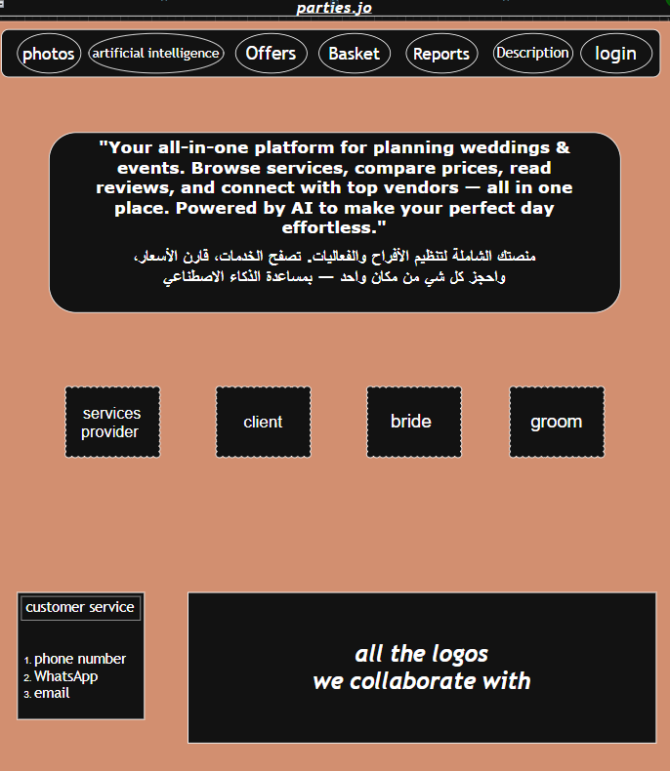

Groom, Bride, Client Page

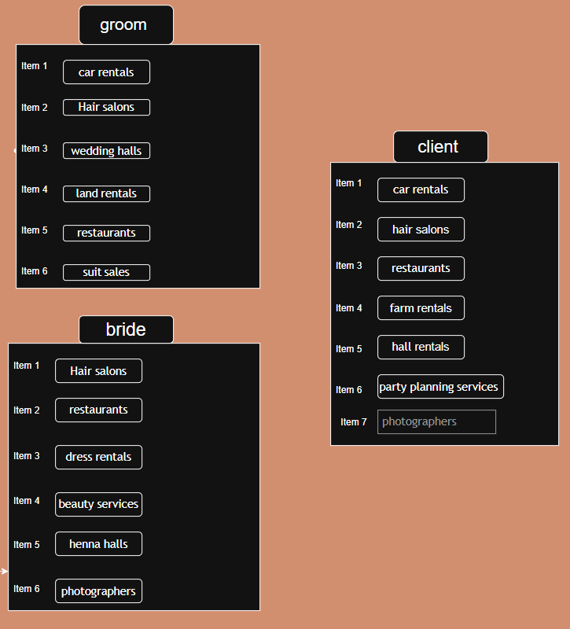

Service Provider page
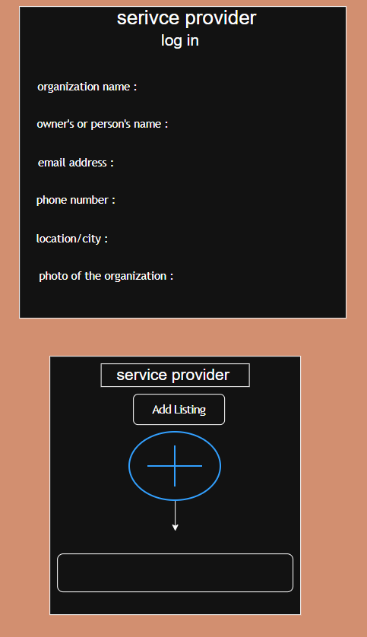

MOCKUPS

Homepage

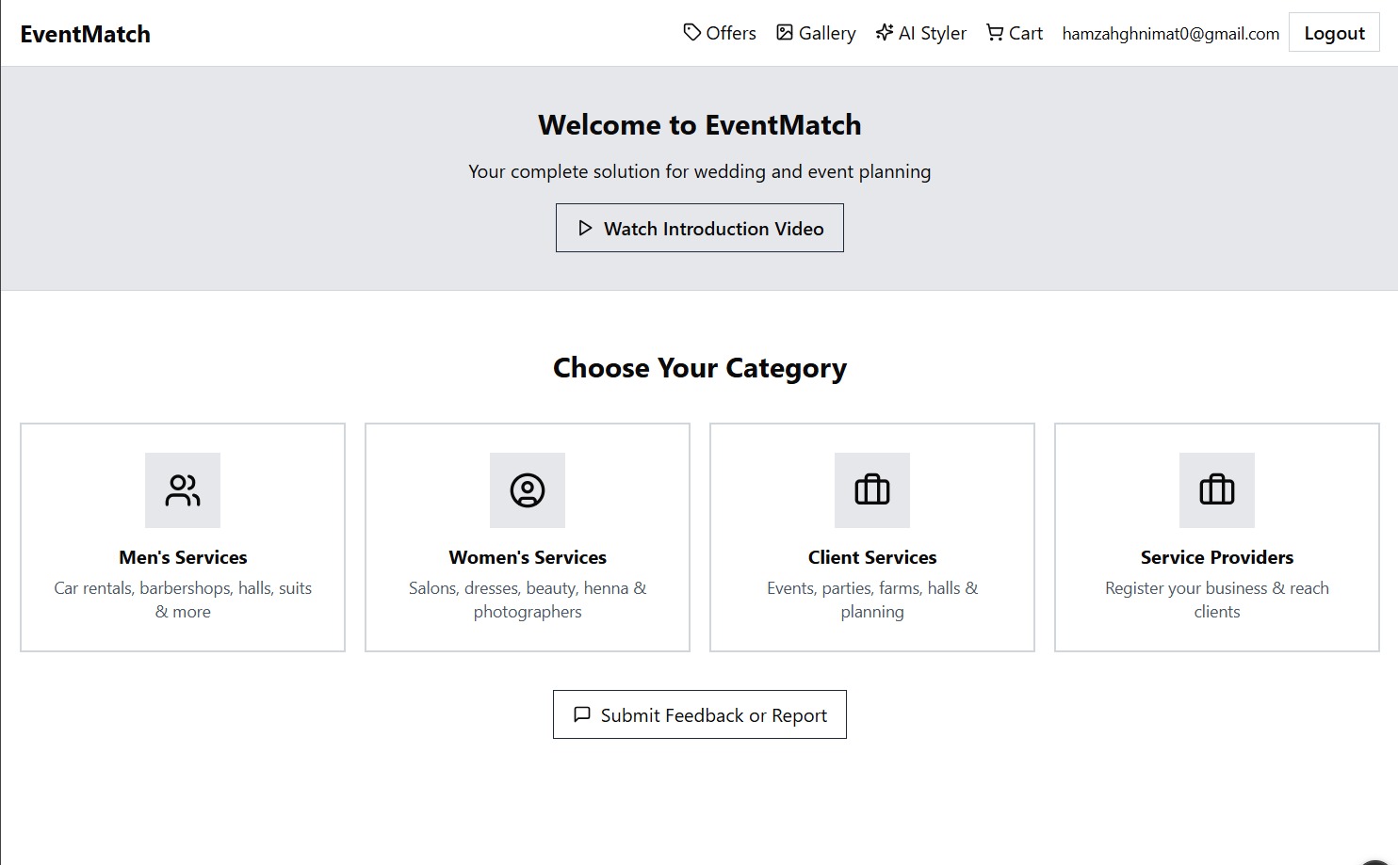

Service provider page
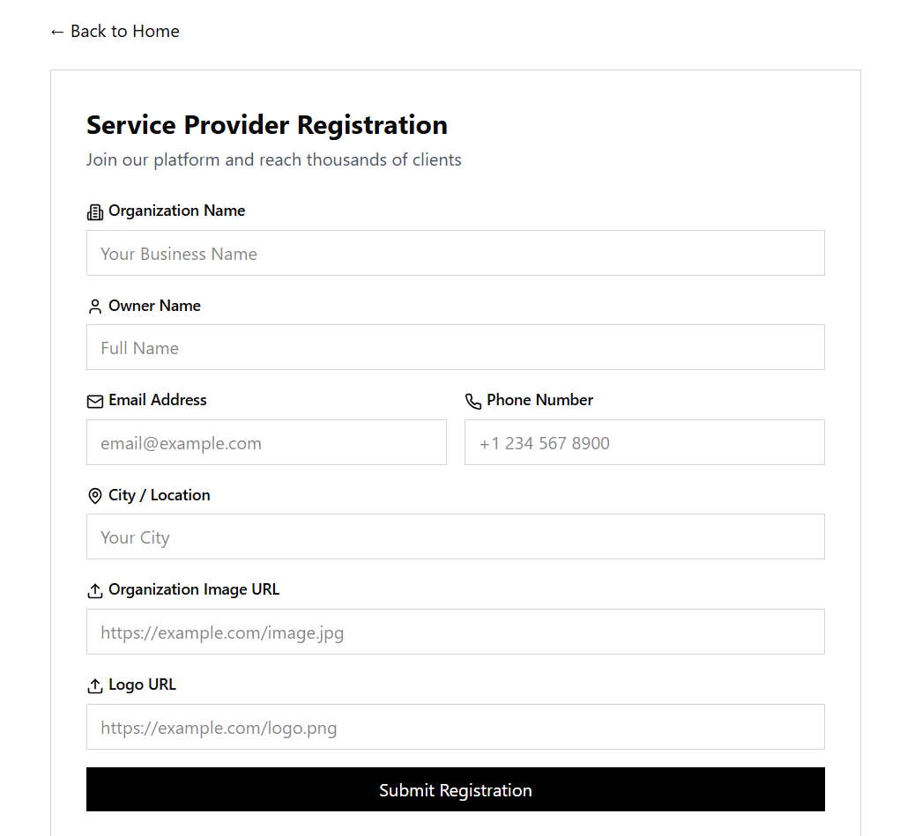

women’s page
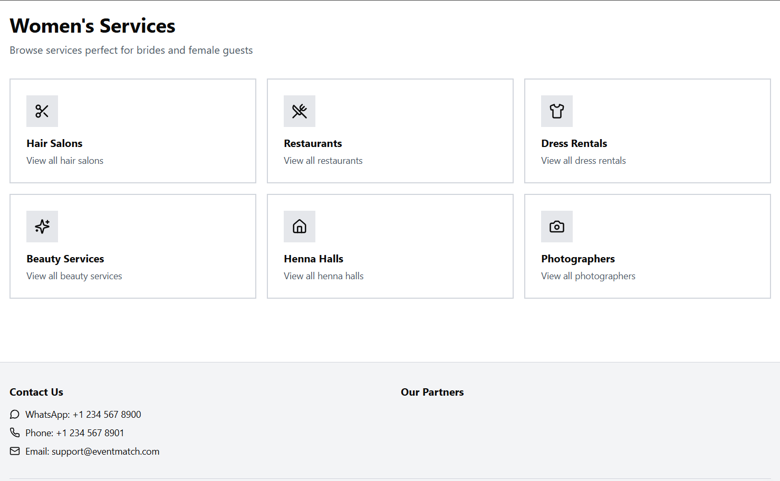
basket page

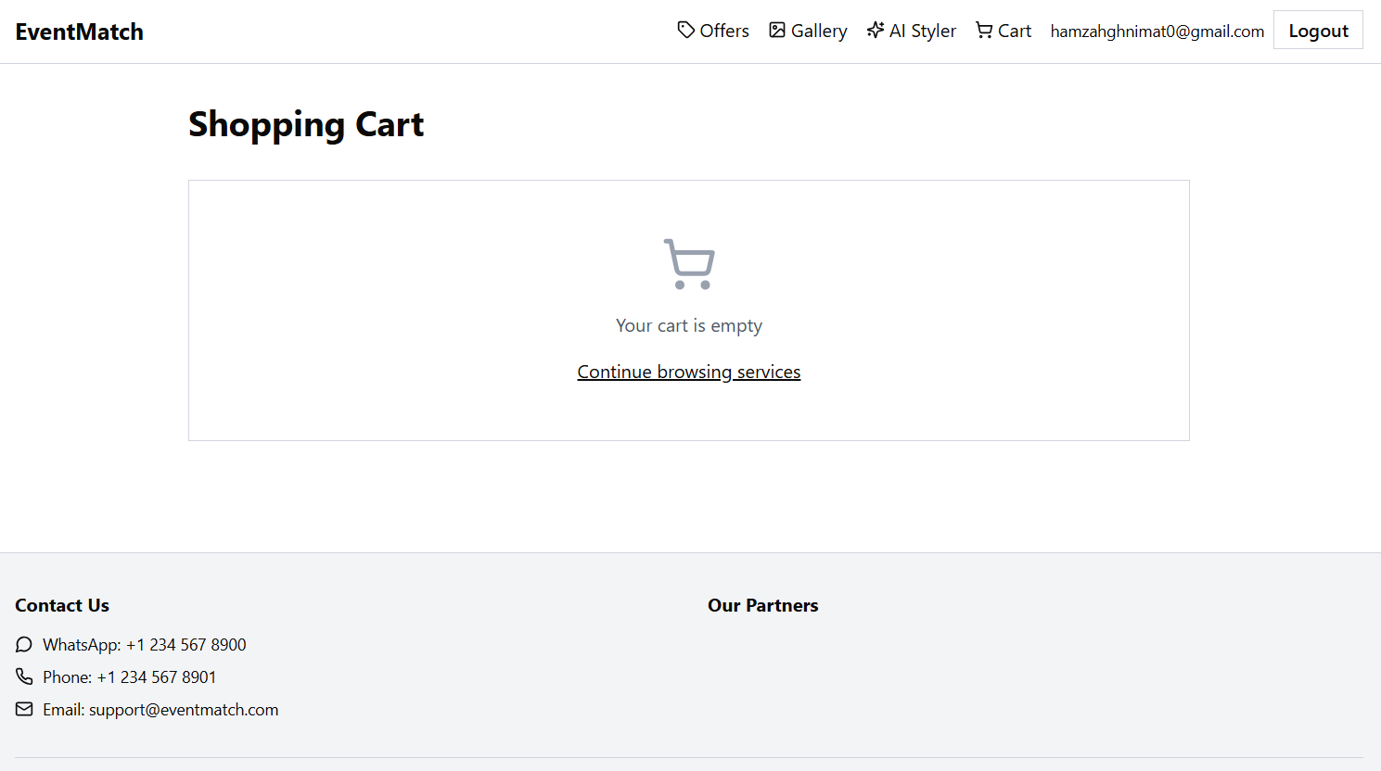

Manager page
